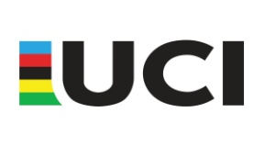

2019 Yangyang BMX International Technical Guide

For inclusion on the UCI International BMX calendar, the organizer shall submit documentation including the following information:

1. **GENERAL INFORMATION**

|  |  |
| --- | --- |
| NAME of the event | 2019 Yangyang BMX International |
| Class of the event | Class C1 |
| Location of the event | Yangyang international cycling park, Yangyang,  Gangwon Province, Korea |
| Date of the event  (competition days) | 23 June 2019 |

1. **CONTACTS**

|  |  |
| --- | --- |
| Organizing committee | Korea Cycling Federation  Address: Olympic Convention Center,  424 Olympic-ro, Songpa-gu, Seoul Korea  Zip Code / Town: Seoul 05540  Tel: +82-2-420-4247~9  E mail: [cycling.bmx@sports.or.kr](mailto:cycling.bmx@sports.or.kr)  Website: <http://bmx.cycling.or.kr> |
| Contact person within the organization | Ms. Sunwoo Sarang : Manager of BMX Department  Tel: +82-2-420-4247~9  E mail: cycling.sr@sports.or.kr |

1. **REGISTRATION**

|  |  |
| --- | --- |
| Registration open | 17 April 2019 |
| Registration deadline | 31 May 2019 |
| Onsite registration possible | No onsite registration. (Only E-mail registration) |
| Number plates for participants | The organizer will distribute plates to participants |
| Other relevant info | All participants must register to UCI affiliated federation and must show their valid UCI license distributed by UCI affiliated federation when registering at the Race Venue |

1. **ENTRY FEES**

|  |  |  |
| --- | --- | --- |
| CLASS | Pre Registration | Registration on Site |
| Challenge | KRW 30,000 or USD 30 | No registration on site |
| Women/Men Junior | KRW 80,000 or USD 80 | No registration on site |
| Women/Men Elite | KRW 80,000 or USD 80 | No registration on site |
| BANK ACCOUNT INFO | Onsite payment | |
| Other relevant info |  | |

☞Foreign Athletes can pay the entry fees on site when registering

ARACE PARAMETERS

|  |  |
| --- | --- |
| Championships categories | Events are open to all riders being licensed by a UCI affiliated national federation.  Event Format : 3 Motos to Final |
| Challenge categories | Events are open to all riders being licensed by a UCI affiliated national federation.  Event Format : 3 Motos to Final |

1. **PRIZE MONEY**

Enclose Prize Money scale for junior and elite categories under the UCI Financial Obligations for BMX

|  |  |  |
| --- | --- | --- |
|  | MEN  ELITE | WOMEN  ELITE |
| C1 | C1 |
|  |  |  |
| 1st | 640€ | 640€ |
| 2nd | 320€ | 320€ |
| 3rd | 160€ | 160€ |
| 4th | 140€ | 140€ |
| 5th | 120€ | 120€ |
| 6th | 100€ | 100€ |
| 7th | 80€ | 80€ |
| 8th | 60€ | 60€ |
| Total | 1,620€ | 1,620€ |

|  |  |  |
| --- | --- | --- |
|  | JUNIORS  MEN | JUNIORS WOMEN |
| C1 | C1 |
|  |  |  |
| 1st | 280€ | 280€ |
| 2nd | 140€ | 140€ |
| 3rd | 100€ | 100€ |
| 4th | 60€ | 60€ |
| 5th | 40€ | 40€ |
| 6th | 32€ | 32€ |
| 7th | 24€ | 24€ |
| 8th | 16€ | 16€ |
| Total | 692€ | 692€ |

**☞ Taxes will be reductted**

1. **ACCREDITATION**

If applicable: note accreditation process and people who are eligible for accreditation

All entrant shall be bring own license distributed by UCI affiliated federation.

All riders must indicate Accreditation Cards which provided by the organizer at venue.

1. **PRACTICE SCHEDULE + COMPETITION SCHEDULE**

Insert Practice and competition schedule for all categories

22 June Saturday

10:00-10:30 Meeting with PCP & Organisers

10:30-11:30 Meeting with Commissaires panel

11:30-13:00 Registration at Race Site & Licence control

13:00-13:45 Official Practice(Under12)

13:45-14:30 Official Practice(Under18)

14:30-15:15 Official Practice(Junior)

15:15-16:00 Official Practice(Elite)

16:00-16:30 Team Manager’s Meeting

23 June Sunday

10:00-10:30 Challenge Class Official Practice

10:30-11:00 Championship Class Official Practice

11:00-11:100 Opening Ceremony

11:10-15:300 Races

15:30-00:00 Awarding Ceremony, Closing Ceremony

(Subject to change without prior notice)

1. **TEAM MANAGERS METTING**

|  |  |
| --- | --- |
| Date and time | 16:00, 22 June 2019 |
| Location | Yangyang BMX Track |
| Other relevant info | 338, Soryang - myeon, Yangyang - gun, Gangwon- do. |

1. **TRACK**

UCI certified track ☐ YES ■ NO

|  |  |
| --- | --- |
| Track + Starting hill Height | Traditional Style Starting Hill Height : 4.5M |
| Track length | 320 m |
| Track surface | Dirt. Each berms with brick |

|  |
| --- |
|  |

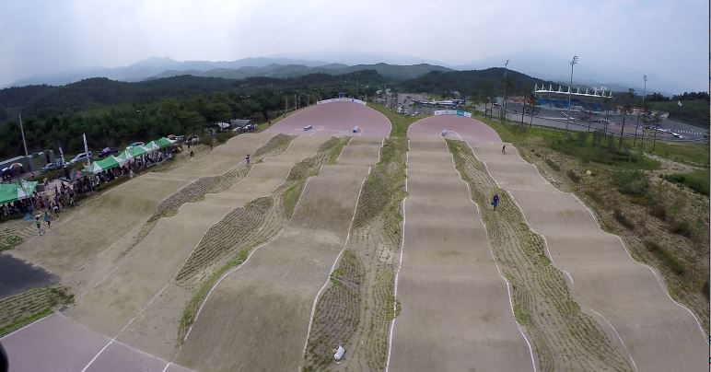

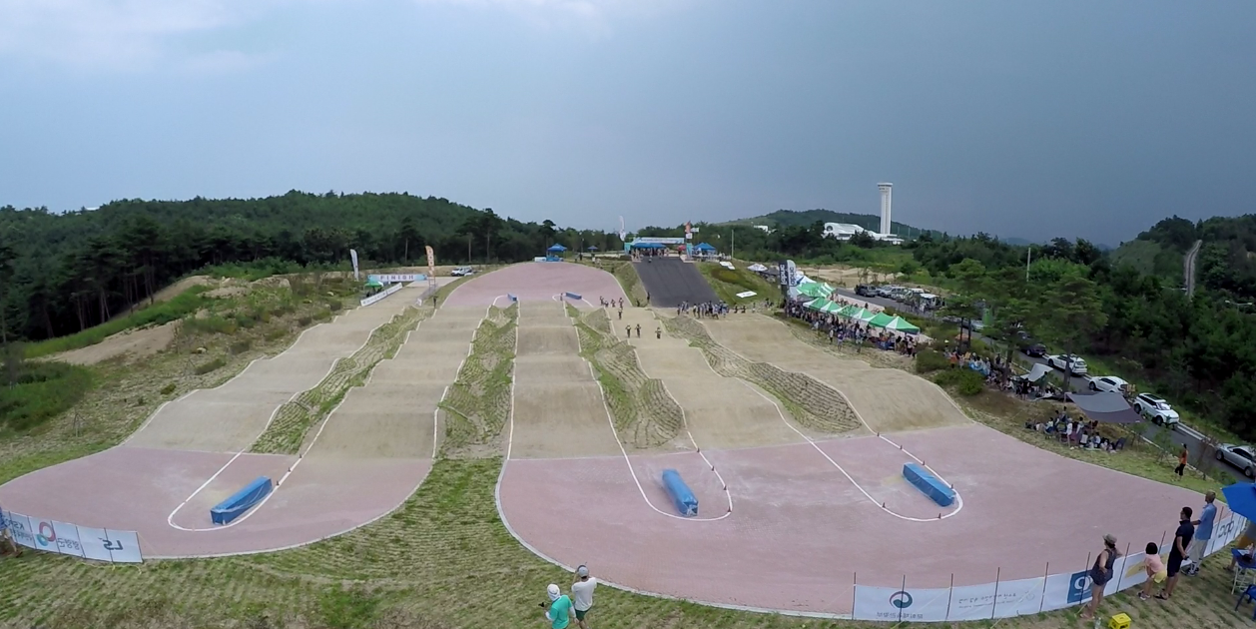

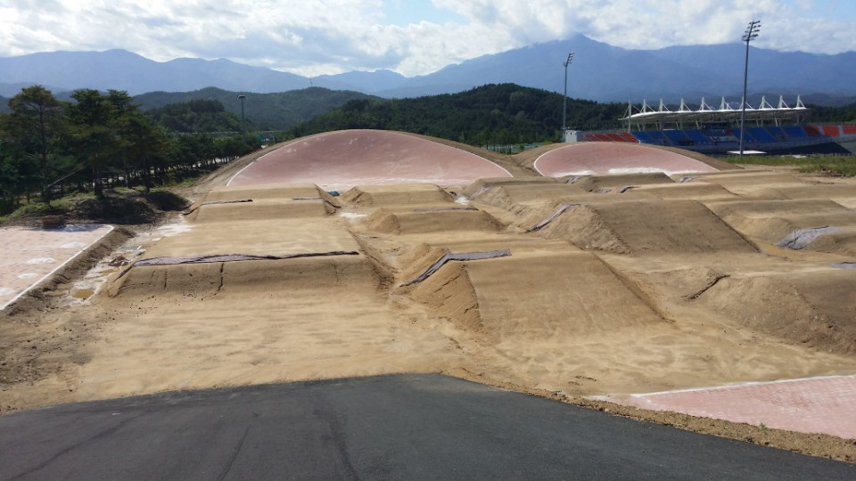

1. **VENUE MAP**

Insert a map or picture of the venue with clearly marked:

1. Track
2. Staging area
3. Team area
4. Grandstands (if applicable)
5. VIP (if applicable)
6. Parking
7. Catering
8. Shops
9. Medical service
10. **OTHER RELEVANT INFO**

|  |  |
| --- | --- |
| Award ceremony | Awards 1st ~ 3rd place, each category  Prize money for Elite Men and Elite Women,  Prize money for Junior Men and Junior Women |
| Anti Doping Control | All entrants must agree to submit to the standard KADA (Korea Anti Doping Agency) testing for the use of banned substances and method. |
| Press conference | 16:00, 22 June 2019 at Yangyang BMX park office  (subject to change) |
| Transport | 5 minutes on foot from Yangyang international airport to the race venue  5 minutes on foot from the nearest hotel to the race venue |
| Nearest Hospital | Yangyang orthopedics Hospital  Tel : +8233-672-6723  9-1 Yangyang-ro, Yangyang-eup,  Yangyang-kun, Gangwon Province, Korea |
| Shuttle bus  **☞ It is subject to change**. | From Incheon airport terminal 1 to HQ hotel : 13:00pm on 21 June  From HQ hotel to Incheon airport terminal 1 : 6:00am on 24 June |
| Names of the Key persons? | - Race director  JANG Eungi  - Track manager  SIM Jongseok  - Medical manager  LEE Jaechul  - Race secretariat/office  KIM Kyoungbum |

1. **ACCOMMODATION**

Enclose info on the nearest hotels(HQ hotel)

Yangyang International Airport Hotel

 Address : 2338 Dongheadaelo. Sonyang-myeon Yangyang-Kun, Gangwon Province, Korea

Website: <http://yangyanghotel.com/>

Distance from Airport to Hotel : 247km (It will take about 3 hours and 30 minutes.)

Distance and time taken (by car) from the Hotel to the BMX track-vanue : 5min

**★Attachments ::** 1. 2019 Yangyang BMX International entry form.