2019 YANGYANG BMX International

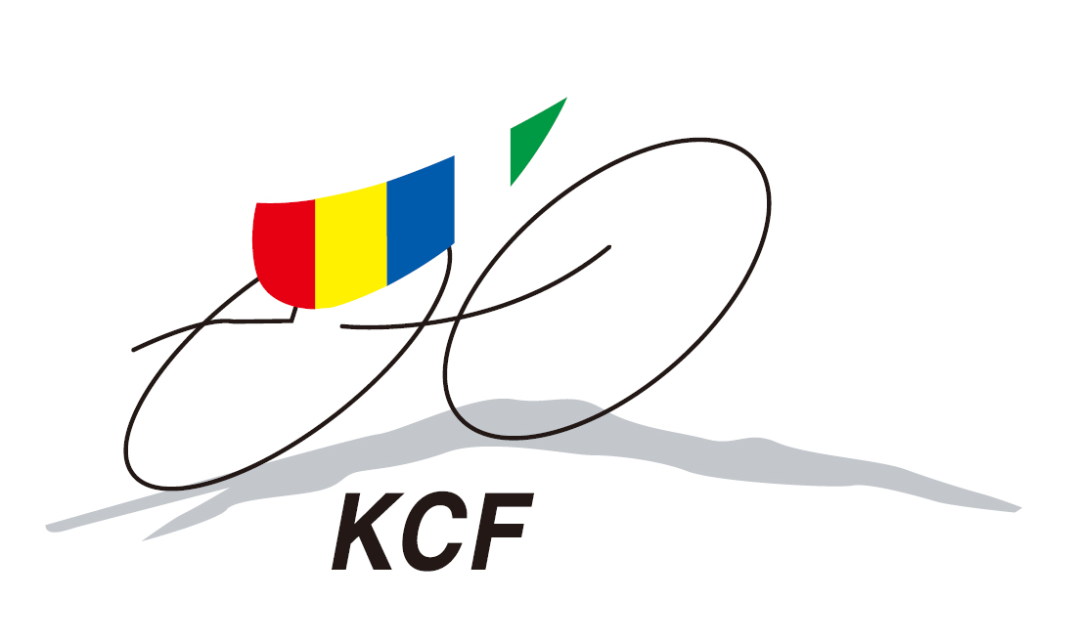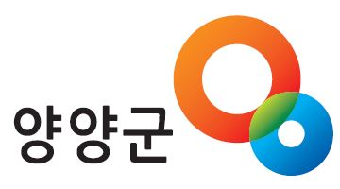 17, April 2019
Submitted until 31 May 2019 (Mail to_ cycling.bmx@sports.or.kr)
First Name |  | Last Name
Team |  | Nationality
Date of Birth  (DD/MM/YY) |  | Gender
UCI ID |  | Category/Class
E-mail |  | UCI Plate Number
Address

DISCLAIMER
I, the undersigned, agree and understand that there are inherent risks and dangers attached to the sport of BMX. I agree to assume solely, full responsibility for all damage of any nature that I might case to third parties. Moreover, in consideration of the acceptance of my registration at the event as a competitor, I hold free and harmless from any liability Korea Cycling Federation(KCF), YANGYANG BMX park, City of YANGYANG its administrators, its organizing commmittee, its employees, its representatives, its volunteer, all sponsors and organization involved in this event. I therefore waive my right to claim and my right of action against each and person mentioned in the foregoing lines in relation with the occurrence of any loss, damage or injury of any nature that I might sustain regarding this event, before, during and after its happening.

Rider’s Signature Date M/ D/ 2019
Parent’s Signature Date M/ D/ 2019

Note: The disclaimer must be signed by the parent guardian of a competitor under 18 years of age or the registering competitor, if 18 years of age or older. This is a condition of entry: failure to meet this condition will result in non acceptance of entry.
Korea Cycling Federation 2019.

